**Contents**

**1.** **Introduction** 5

**1.1.** **Overview of AEC Industry** 5

**1.2.** **Technology Implementation in AEC Industry** 6

**1.3.** **Development of AEC Industry under Smart City Paradigm** 8

**1.4.** **Scope of Research** 9

**1.5.** **Statement of Ethics** 9

**2.** **Literature Review** 10

**2.1.** **Control Room** 10

**2.2.** **Application of Digital Twin Paradigm** 10

**2.3.** **Digital Twin in AEC Industry** 11

**2.4.** **Research Gap** 12

**2.5.** **Features Digital-Twin based Control Room in AEC Industry** 12

**2.5.1.** **Information Management** 12

**2.5.2.** **Visualisation – Immersive Virtual Reality** 13

**2.5.3.** **Visualisation - Dashboard** 14

**2.5.4.** **Connectivity** 14

**3.** **Methodology** 15

**3.1.** **Research Method** 15

**3.2.** **System Architecture of the Control Room** 15

**3.2.1.** **Data Layer** 16

**3.2.2.** **Data Services Layer** 16

**3.2.3.** **Application Layer** 16

**3.3.** **Source of Data** 17

**3.3.1.** **Model Data** 17

**3.3.2.** **Project Performance Data** 17

**3.3.3.** **Sensor Data** 18

**3.3.3.1.** **Field** **Condition** 19

**3.4.** **Information Management** 20

**3.4.1.** **BIM 360** 20

**3.4.2.** **Microsoft Azure** 21

**3.4.2.1.** **Database Management** 22

**3.4.2.2.** **Streaming of Sensory Data** 23

**3.5.** **Data Visualisation** 24

**3.5.1.** **VR** 24

**3.5.2.** **Dashboard** 25

**3.6.** **Connectivity** 26

**3.7.** **GitHub Repository** 26

**4.** **Result & Discussion** 27

**4.1.** **BIM360** 27

**4.1.1.** **Document Management** 27

**4.1.2.** **Design Collaboration** 28

**4.1.3.** **Project** **Management** 29

**4.1.4.** **Limitations** 30

**4.2.** **VR** 32

**4.2.1.** **Project Perception** 32

**4.2.2.** **Safety Hazard Identification** 33

**4.2.3.** **Limitations** 34

**4.3.** **Dashboard** 36

**4.3.1.** **Identify Insight from Safety Record** 36

**4.3.2.** **Monitoring the Working Environment** 38

**4.3.3.** **Limitation** 39

**4.3.4.** **Recommendation** 39

**4.4.** **Connectivity with External Applications** 40

**4.4.1.** **Challenges** 40

**4.4.2.** **Recommendation** 41

**4.5.** **Day-to-Day Routine of Control Room** 42

**4.6.** **Future Development (200 words)** 43

**5.** **Conclusion (300 words)** 44

**6.** **Reference** 45

**7.** **Research Log** 47

**8.** **Appendix** 48

List of Figure

Figure 1 McKinsey Global Institute industry digitalization index (McKinsey, 2015) 7

Figure 2 System Architecture of Control Room 15

Figure 3 BIM Model visualised in the Autodesk Revit 17

Figure 4 Control Room Home Page 20

Figure 5 Overview of modules in BIM 360 21

Figure 6 Azure IoT Ecosystem extracted from Microsoft Azure Cloud Service 23

Figure 7 Extract from Azure Stream Analytics 24

Figure 8 Comparing the difference between models by BIM 360 Document Management 27

Figure 9 Overview of BIM 360 Design Collaboration Module 29

Figure 10 Different Team member immerse in 3D environment 31

Figure 11 Overview of Prospect 34

Figure 12 Dashboard Visualisation by Power BI - Overview 35

Figure 13 Dashboard Visualisation by Power BI – Tree Diagram 36

Figure 14 Line Chart Visualisation of Sensory Data by Power BI 37

List of Table

Table 1 Technical Specification of Raspberry Pi and Sensors 18

Table 2 Table Summary of Construction Performance Data in SQL Server Database 23

Table 3 Table Summary of sensor data in Power BI 24

Table 4 Specification of Oculus Quest 25

# **Introduction**

# **Overview of AEC Industry**

Architecture, Engineering and Construction (AEC) industry is one of the largest industries in the global economy. There is about $10 trillion spent on construction-related activities over the world annually, which is equivalent to 13 percent of GDP. There is also 7 percent of working population around the world working in this industry (McKinsey & Company, 2017). However, the productivity of AEC Industry is lagging the global productivity by over 30% and 98% of infrastructure projects are over budget or delayed around the world (Changali et al., 2015).

As AEC industry is complex and dynamic in nature (Mohd Nawi et al., 2014), it consists of multiple disciplines at various stages such as planning, design, construction, and operation. The disciplines can be ranged from structural, building services, civil, mechanical engineering teams and architect who are involved from the beginning until the completion of the construction project. Over the years, the project delivery practice among these parties are notorious for poor in collaboration such as isolation of working and inadequate co-ordination. As construction projects can involve thousands of work tasks which are interrelated, so if one individual task is not managed properly, it would significantly impact the quality and productivity of the works in future stages.

Apart from that, the information management in construction is not effective enough. The AEC Industry is labour-intensive and generates enormous amounts of information including calculation, drawings, project reports, tender documents, ...etc which are produced of a construction project. According to a research in China (Xu & Luo, 2014), it has identified and discussed many consequence on the poor collaboration and information transfer among different parties, such as the loss and inconsistent of information caused by fragmentation of parties and unorganised information system. There is a comprehensive statistic of two typical sites in middle and North China, it shows that around 43%, 12%, 3% of the project time lost due to inconsistent information, dislocation, and ambiguity respectively on a construction project in average.

Health and safety deficiency are also one of the main concerns as compared to other industries. The AEC industry has long been recorded with the highest number of death and accident rate compared with other industries globally. It is about 79,000 workers in the construction industry in Great Britain suffered from work-related ill health such as depression and musculoskeletal disorders and 30 fatal injuries in 2019 (HSE, 2019). There was about 62% of construction workers suffering from musculoskeletal disorder. The rate is significantly higher when compared with the rate for workers across all other industries, which is only 1.2% [ibid].

# **Technology Implementation in AEC Industry**

As the AEC industry is embracing the digital age, the construction processes should be enhanced by technologies such as dealing with value-added monitoring of data and optimisation of engineering systems. However, the AEC industry is far behind to adopt new technology compared with other industries. The digitalization index of construction is very low as shown on Figure 1(McKinsey, 2015).

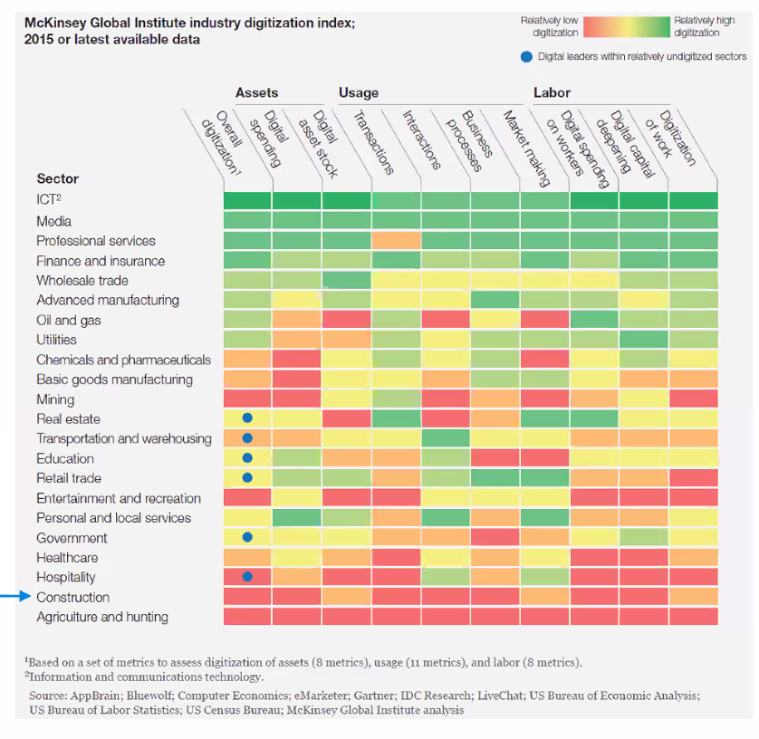

Figure 1 McKinsey Global Institute industry digitalization index (McKinsey, 2015)

Apart from the low adoption of technology, the common practise of adoption of the technological solution in AEC industry was ‘point solution’ focus (Woodhead et al., 2018). “Point solution” means the solution with a singular focus on one problem and with one use-case only. An example cited by this literature pointed out that a typical Project Planning application used today which is disconnected from what is happening in the supply chain, on site, meteorological risks etc. The singular focus will lead to silo-solution that cannot make gather different parties to solve the problem and cannot make good use on the data. For the construction companies to adopt the technology solution effectively, it also pointed out that they should recognise a “planned IoT ecosystem” will provide a long-term advantage rather than trying to combine many “point solutions”. The ecosystem means an integration of hardware, software, connectivity, and information flows that linked together for making key decisions based on data (ibid).

Besides, the explosion of global pandemic COVID-19 triggered the development of digital transformation in different industries (Chhaya et al., 2020). With unprecedented consequences such as the disruption of manufacturing and supply chains, the mitigation to the impact by COVID-19 requires new approach of working and forms of collaboration to increase overall resilience of the business with technology.

# **Development of AEC Industry under Smart City Paradigm**

Nowadays, the smart city development strategy is embraced over the world, which is focused on “citizen centric” (Lara et al., 2016). It proposed that the technology should be citizen-focused, the developer must understand their citizens need and develop appropriate technologies which will be beneficial to them. This citizen-centric value defines the initiative Project 13 in AEC industry, which aims to develop a new business model for delivering high performing infrastructure to the ultimate user (i.e. the citizen). There is an ‘Integrator’ character which can be a single company or a collective party who plans and delivers the infrastructure programme, manages the suppliers and advisors, oversees design, construction, maintenance and operations as requested by the owner (Engineers, 2018). Most importantly, it pointed out that the Integrators should bring together capabilities to deliver effective solutions through production systems and enables a platform approach to deliver the project stipulated under the “Integration” pillar of the five pillars in the initiative (ibid). Regarding to this, an integrated platform such a Control Room should be considered to improve the project delivery in AEC industry.

# **Scope of Research**

The major scope of research of this study is as follows:

* Explore what are the features of the Control Room for AEC industry
* Explore how the Control Room’s features to enhance the project delivery based on available solutions in the market
* Explore the improvement on Control Room’s features based on the evaluation on current available solution

# **Statement of Ethics**

All the data used in this study do not contain any personal information. Therefore, no ethics approval was required.

# **Literature Review**

# **Control Room**

The Control Room idea was originated in 1920s, which is for production control and monitor the physical facility in a central space (Bennett, 1993) . In 1970s, the launch of Apollo 13 program by NASA make use of the Control Room for monitoring the outer space condition (Jarrett Hendricks, 2020). The engineers on the ground Control Room needed to response the changes swiftly to the space vehicle and the astronauts exposed to the extreme conditions in outer space. Later, NASA identified that they can no longer make corrective decisions based on the original modelling method because the actual module had subjected to significant changes due to the exposure under extremely hostile environment. It was necessary to update the original modelling method so that the actual state of the module could be closely simulated. As a result, they used the “pairing technology” to simulate the outer space with the mathematical models so that the engineers and different professionals could collaborate in the Control Room on ground and made decision based on that mathematical model (ibid).

Pairing Technology is the precursor to the digital twin paradigm in the fourth industrial evolution. The core idea of the digital twin is to create a virtual asset to represent the physical assets, which helps the company to make better-informed decisions to improved outcomes in the real-time (Bolton et al., 2018). It shows that the digital twin paradigm plays a fundamental basis of the Control Room.

# **Application of Digital Twin Paradigm**

There is an example of product manufacturing industry to show how to utilise the digital twin paradigm. A digital-twin based production management and control system has been used for complex products development (Yi et al., 2020). The product digital twin acts as a single data source to support for the collaboration between vendors throughout the product lifecycle, which are product design, process planning, product assembly, product use and maintenance.

Besides, during the life cycle, the enormous amount of shop-floor data can be visualised and integratory managed based on digital twin approach. Take the assembly stage as example, the assembly shop-floor digital twin is composed of shop-floor production elements’ geometric models to represent the physical models such as shop-floor model, production line models, assembly station models, manufacturing resource models, product models, and environment models (Zhuang et al., 2018). And they contain full element assembly process information and assembly process data, which is the same as physical assembly procedures, it facilitates the cyber-physical integration of the product assembly process.

In addition, the IoT technology has also been used to ensure the timeliness demand in manufacturing/assembly shop-floors. For example, the real-time information acquisition, material delivery, work-in-progress (WIP) management, product quality monitoring, manufacturing cost tracking, adaptive production process control can be achieved to ensure the product delivery (Zhuang et al., 2018).

# **Digital Twin in AEC Industry**

AEC industry has similar nature with the product manufacturing industry, the infrastructural projects generates enormous amount of data during the entire project life cycle and It involved multi-discipline teams for collaboration in the projects. Many professionals has already suggested that Building Information Modelling (BIM) should play an important role with the digital twin to form an integrated approach (Boje et al., 2020), as it utilise a 3D model to simulate the building or infrastructure and store various types of information during the entire life cycle. As a result, a digital twin-based Control Room can also be developed to enhance project management and reduce risk like project delay, over-budget and minimise contractual implication and safety deficiencies in AEC Industry.

Besides, the CDBB’s Digital Framework Task Group (DFTG) has introduced the National Digital Twin (NDT) programme in the infrastructure and construction sectors (Bolton et al., 2018). It focused on creating an ecosystem of digital twins which connected each other with securely sharing of data, it could increase the infrastructure resilience by minimising disruption and delays, optimising the use of resources and boost quality of life for citizens.

Based on the similarity between the product manufacturing industry and AEC industry, it shows that the framework of the digital-twin based Control Room in AEC industry can be implemented as follows. First, it should be a platform which can enhance information management and collaboration. Second, it should include digital models paring with the physical facility with the help of IoT device and the data obtained can be visualised and analysed. Third, the digital model should be able to exchange data with other digital systems.

# **Research Gap**

In addition, most of literatures has just pointed out the conceptual framework and the advantages of using the digital twin-based approach in the industry but there is less research on how to implement the digital-twin based Control Room practically with using case study to show how does it work in the AEC industry. For example, the details of architectures to implement the Control Room and how to link these architectures all together to solve problem practically are omitted. This study will try to fill this gap and explorer the following features of a digital-twin based Control Room based on the framework discussed on last session.

# **Features Digital-Twin based Control Room in AEC Industry**

# **Information Management**

It should be a platform to foster the collaboration and information exchange between different disciplines. Traditional tools such as email, project management software and telephone are just one-way communication activities. They lack of real-time collaboration elements which is for connected engagement, discussion and approval process (Levine, 2016). If different parties in the project can submit updates of information on a simple and real-time manner on a single platform to create a single source of truth (i.e. common data environment), it will be easier for all project team members as one and remain on the same pace as the project proceeds, so it would not make the progress delay in terms of scheduling and over-budget due to rework.

Since diﬀerent types of sensors would be installed on the real system, it is essential to use a high-power computational service that represent models for their interactions. One of the solutions is to use a cloud service that oﬀers high ﬂexibility and high processing performance. Cloud computing changes the traditional way of businesses to manage IT resources, which the services such as servers architecture, databases, analytics, business intelligence over the Internet and ensuring data security (Microsoft, 2020). Cloud Computing also eliminates the requirement of using local hardware to handle and process data, thus no need to pay extra cost to buy hardware with high computation power (Stergiou et al., 2018). Therefore, this platform should be cloud-based so that it saves cost and with high computation power.

# **Visualisation – Immersive Virtual Reality**

Immersive Virtual Reality (VR) can give the user feel like physically presenting in a computer-generated environment simulating places in the real or imagined worlds. It is common used in the education and training purpose by its potentials of provide an interactive and motivated environment (Freina & Ott, 2015). Besides, many publications have identified various areas that VR technologies have been implemented to enhance safety (Alizadehsalehi et al., 2019), such as risks identiﬁcation, workforce training, skill transfer and ergonomics in the AEC industry (Li et al., 2018). While VR can also be used for meeting with team members to work together within a 3D model for discussion, which is benefit for remote working (Brandon, 2020). All these literatures showed that VR device is an effective tool for enhancing the interaction between human experiences and building environments.

# **Visualisation - Dashboard**

Dashboard visualisation is a cognitive tool to improve our “span of control” over the business data. This help the managers to identify trends, patterns, and anomalies from the data. Managers can figure out the reason about what they observe and as a guideline for them to make effective decisions. Besides, Key Performance Indicators (KPIs) is commonly used to benchmarking and compare performance by meeting both strategic goals with a dashboard in different industry. The analysis results can help to improve the building processes and risk identification for project delivery. It is the topmost priority for Project Directors, Project Managers and any other person responsible for planning management to implement a better planning process by having a clear view of the project’s status.

# **Connectivity**

A digital twin platform should provide an open API that allows the system to interact with other digital twin such that these systems can be connected and scalable, such as integrating their digital twin into machine learning and analytics services provided by cloud services and enable external applications developed by open source developer. To achieve this, the Control Room platform should provide open Application Program Interfaces (API) such that the more user can utilize the function of the Control Room platform and third-party developers can develop external applications. It motivates more developers to improve the functionally of the entire Control Room system and make good use of the data.

# **Methodology**

# **Research Method**

Based on the features discussed on the last session, some services and software available on the market has been selected to form the system architecture of a digital-twin based Control Room. They will be evaluated with a case study of the residential house design and built project[1] from the Contractor points of view. It will be evaluated by the author himself based on his personal experience to verify the method eﬀectiveness on the information management, data visualisation and connectivity.

# **System Architecture of the Control Room**

The service and software available in the market have been allocated into different layers of the system architecture for the Control Room as Figure 2. It composed of 3 layers which are the Data Layer, Data Services and Application layer.

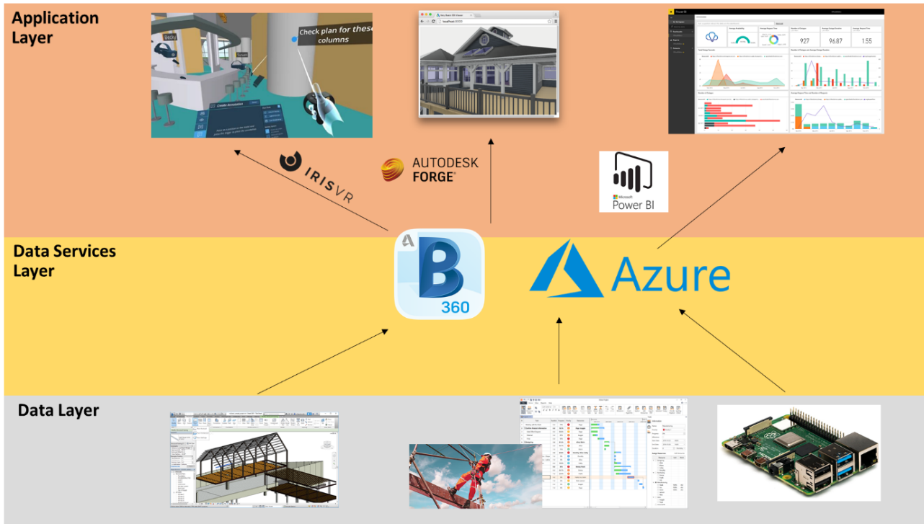

Figure 2 System Architecture of Control Room

# **Data Layer**

Each of the component (from left to right) in the data layer represents an aspect of the construction site to reflect the performance.

* Model data: the digital model of the physical configuration of the building
* Project performance data: Safety data
* Sensory data: Working condition of the construction site

# **Data Services Layer**

This layer demonstrates the information management feature of the Control Room. The model data will be published to the BIM 360 cloud platform for collaboration so that different project team members can modify the model data remotely on a single source of environment. Besides, the Microsoft Azure Services provide a platform with different tools for establishing server-side application. The project performance data and sensory data will be inserted in a SQL Server database which is created with Azure Services. All these data can be retrieved to feed into the elements in application layer for visualisation. Details of these data services will be discussed in Section 3.4 and 3.5.

# **Application Layer**

The application layer demonstrated the data visualisation and connectivity features of the Control Room. Model data in BIM 360 will be visualised in VR environment with the software “Prospect” developed by IrisVR. The project performance data and real-time sensory data will be visualised with dashboard by Microsoft Power BI. While the Autodesk Forge API will be used to retrieve the data from BIM 360 to an external application which is a viewer application. There details will be discussed in Section 3.6 and 3.7.

# **Source of Data**

All the data used in this study will be modified from different source to fit into the novel of the case study.

# **Model Data**

The model data is a template file provided by Autodesk Revit 2020 with format of “.rvt”. The 3D model can be visualised as Figure 3:

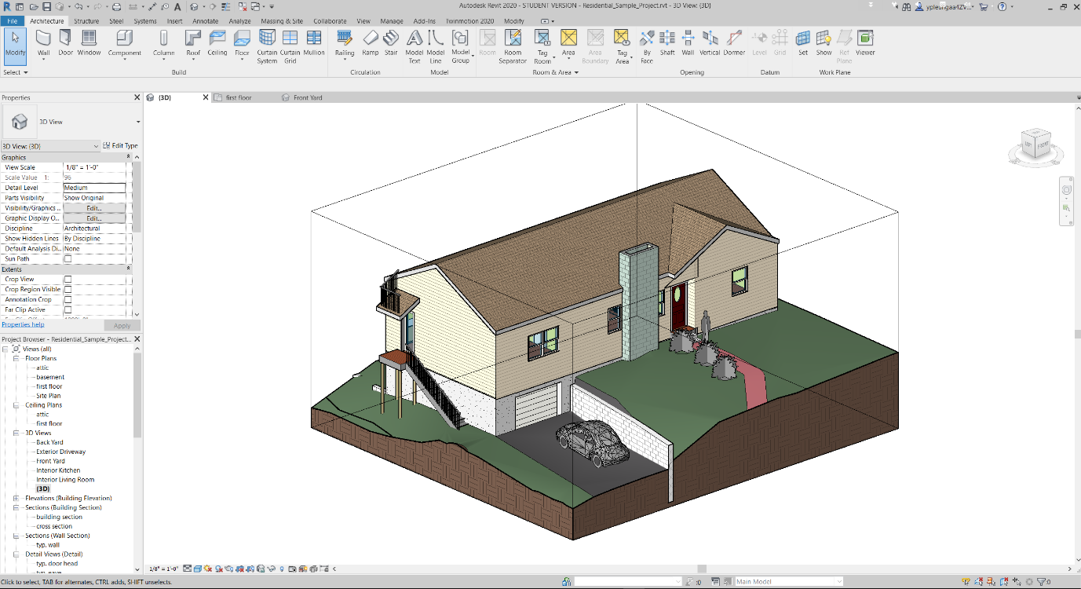

Figure 3 BIM Model visualised in the Autodesk Revit

The model contains objects data relating to the architectural and structural elements. All objects in the model contained information such as object name, type ID, furniture name, material information and major dimensions in object property. All the model data would be processed by Autodesk Revit first and would be published to BIM 360 online to simulate the collaboration features of the Control Room.

# **Project Performance Data**

One dataset of project performance data used for this study is modified from the data provided from the ‘Project Hack 5[2]’ hackathon organised by Project Data Analytics Community. It contains all incident record of the construction project of the residential house from 2016 to 2020, it includes detailed information with 139 rows and 15 columns, such as date of accident, accident category, nature of injury and damage classification and type of contact.

# **Sensor Data**

Low cost microcontroller Raspberry Pi (RPi) has been selected as the prototype of IoT devices to capture the construction environment data. RPi is a Linux-based platform. It is a credit card-sized computer and can be as an alternative of a desktop computer. As it is low cost and support different operating systems, it is suitable for ranges of projects such as acting as IoT device. The version used in this study is the Raspberry Pi 4 Model B which is newly released on the end of May 2020. The RPi can connect with local area networks with WIFI and transfer the data received from the sensors to Microsoft Azure IoTHubs services, which will be explained in Section 4.4.1. The technical details are given in the below Table:

Table 1 Technical Specification of Raspberry Pi and Sensors

|  |  |  |  |
| --- | --- | --- | --- |
| **Component** | **Image** | **Relevant Technical Data** | |
| Raspberry Pi 4 Model B | Raspberry Pi® 4 B 4 GB 4 x 1.5 GHz Raspberry Pi® | Conrad.com | Cost:  RAM  Processor  Operating  Voltage | 68 pounds  8GB  Broadcom BCM2711, Quad core Cortex-A72 (ARM v8) 64-bit SoC @ 1.5GHz  5V DC via USB-C Connector (minimum 3A) |
| SHT20 | SHT20 溫濕度傳感器模組I2C 通訊- 台灣物聯科技TaiwanIOT Studio | Cost  Interface  Temperature Range  Humidity  Range  Operating Voltage | 3 pounds  I2C  -40oC to +125 oC  0 to 100%  3.3V |

# **Field** **Condition**

Under the disruption of COVID-19, it is hard to find an actual construction site for capturing the sensory data for our study. As a result, the sensory system had installed on a local factory which manufactures hangers in Hong Kong as Figure 4to simulate the working condition of a construction site and the ability of the sensor to collect the empirical data. The usable area of the factory is around 75 sq. feet and height 12 feet. One worker is working in this factory from 09:00 to 17:00 from Monday to Friday to keep on monitoring and maintaining the machineries which produce the hangers and process the raw material inside the factory. The temperature and humidity of working environment will be impacted when the machineries are operating. As a result, it is a reasonable location to be chosen to simulate capturing data in a construction site. For this study, one sensor box (add photos) will be installed at the factory for demonstration purpose. The data will be captured from xx:xx:xx to xx:xx:xx on xx August 2020.

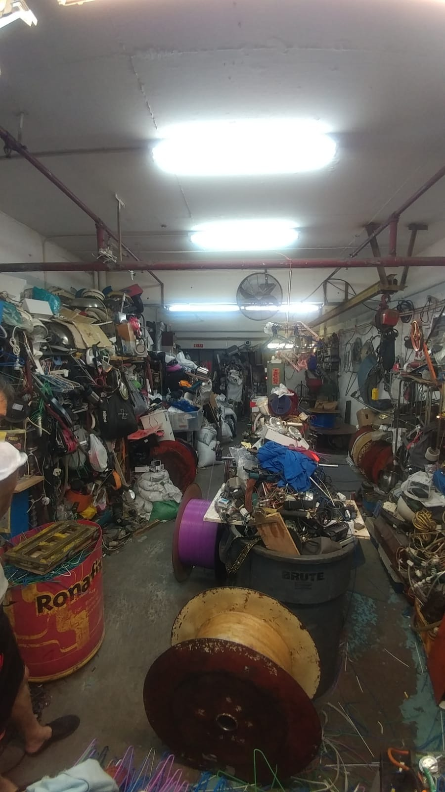

Figure 4 General Layout of the Factory

# **Information Management**

# **BIM 360**

BIM 360 is a common data environment (CDE) and a collaboration platform. This cloud service is used to demonstrate the collaboration and information management features of a Control Room. On the “Project Home” page of this platform , it allows users to add different customised card such as the status of the project issue, RFI, model and even insert the Power BI dashboard, which provide a great integration capability to organise different kinds of information for the Project Engineers to Project Director. A snapshot of Project Home page is shown on Figure 5*.*

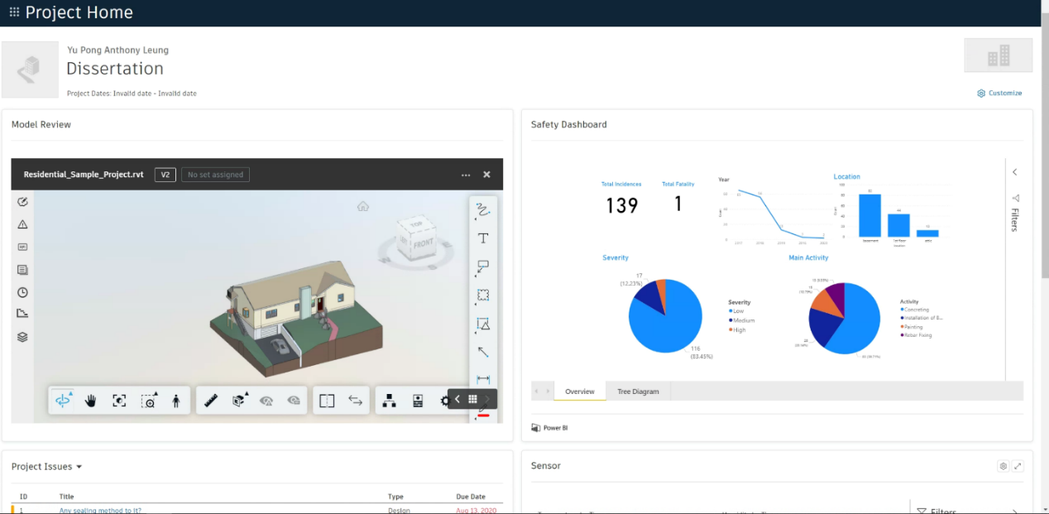

Figure 5 Control Room Home Page

Besides, this platform provides different modules as Figure 6 to enhance the collaboration of different parties and managed the information. The modules such as “Document Management”, “Project Management” and “Design Collaboration” will be used in this study. As a construction project contains lots of drawings and BIM model data, these documents will be stored in the module Document Management which supports version control and provides ways to keep track on every single step on the workflow. The Project Management module will be used to show how the Request For Information[3] (RFI) issued by different parties can be accounted for step by step and keep on monitoring to ensure they can be answered on time and with no ambiguity. Design Collaboration module will be used to show how BIM model packages be created by different parties on a timeline and will allow them to decide whether to consume these packages for their further amendment on the BIM model. This service has been used in this study since it is the only one solution that provides trial version for education purpose in the market.

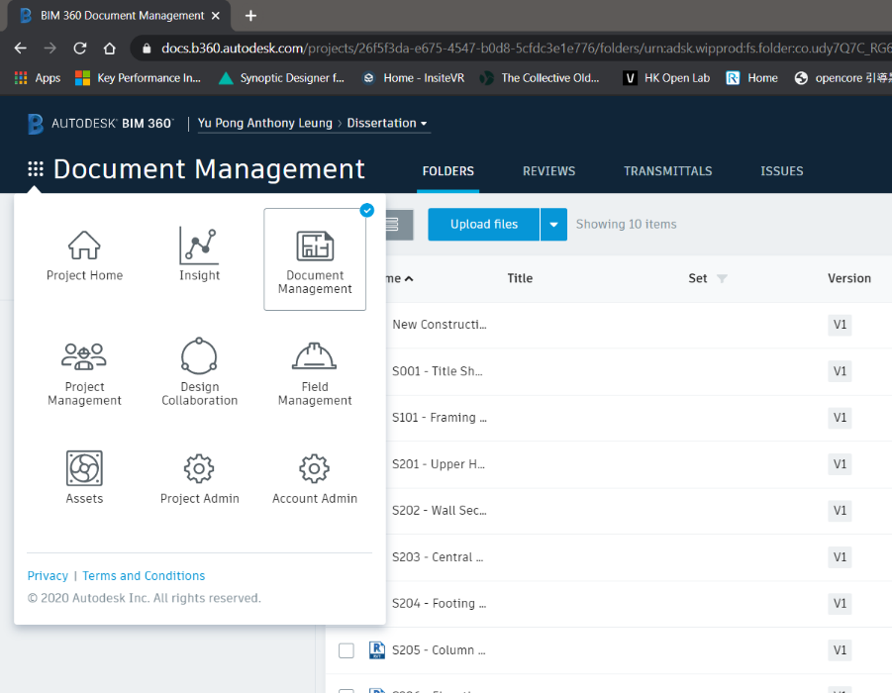

Figure 6 Overview of modules in BIM 360

# **Microsoft Azure**

Azure is used to demonstrate how it support the information management and data visualisation features of the Control Room in this study. It offers cloud service in three main categories: Infrastructure as a Service (IaaS), Platform as a Service (PaaS), and Software as a Service (SaaS). PaaS will be focused on this study. Platform as a service (PaaS) is a cloud-based development and deployment environment, with resources to deliver our own applications.

PaaS not only includes the elements of IaaS such as servers, storage, and networking, it also provides middleware, development tools, business intelligence (BI) services, database management systems and so on. It is designed to support the full development of the lifecycle of a web application like building, testing, deploying, managing, and updating. Compared with other cloud service, the Azure also provides a user-friendly environment and tools for the developer to build their own application, the building blocks is clear to build the new application. Also, as Azure support directly push the real-time data to Power BI, which provides an easy way to set up real-time visualisation of sensory data.

Microsoft Azure cloud service is the only one in the market to offer a free tier one-year subscription for students, which is a great choice for this study.

# **Database Management**

Azure SQL Database is a fully managed PaaS database engine that handles most of the database management functions such as upgrading, patching, backups, and monitoring without user involvement. With Azure SQL Database, a highly available and high-performance data storage layer for the applications and solutions can be created. It also allows the process of both relational data and non-relational structures, such as graphs, JSON, spatial, and XML. A script was used to create a table in SQL Server Database and insert the dataset in .csv format from python to the table was attached in Appendix XX, It established a connection to the SQL Server with the required credentials to perform inserting to the database. Python Libraries such as panda and pyodbc will be used for data processing and building connection with the SQL Server.

Table 2 Table Summary of Construction Performance Data in SQL Server Database

|  |  |  |  |
| --- | --- | --- | --- |
| **Table Name** | **Field** | **Type** | **Description** |
| SAFETY | activity | Text |  |
| actual_closure_date | Date |  |
| ai_category | Text |  |
| body_part | Text |  |
| date_of_accident | Date |  |
| date_of_report | Date |  |
| id | Whole Number |  |
| investigation | Text |  |
| investigation_level | Text |  |
| location | Text |  |
| nature_of_injury | Text |  |
| no_of_days_lost | Date |  |
| target_closure_date | Date |  |
| type_of_contact | Text |  |

# **Streaming of Sensory Data**

For the sensory data, the sensor with the microcontroller Raspberry Pi (RPi) act as a node and registered as an ‘IoT devices’ in Azure IoT Hubs. The python script attached in Appendix xx has been executed on the RPi to connect with the IoT Hubs. RPi has set to send data every 10 seconds. By using the IoT Hubs services as the gateway, the data can be further processed with the Stream Analytics to push to another application as Figure 7 referenced from the Microsoft Azure Cloud.

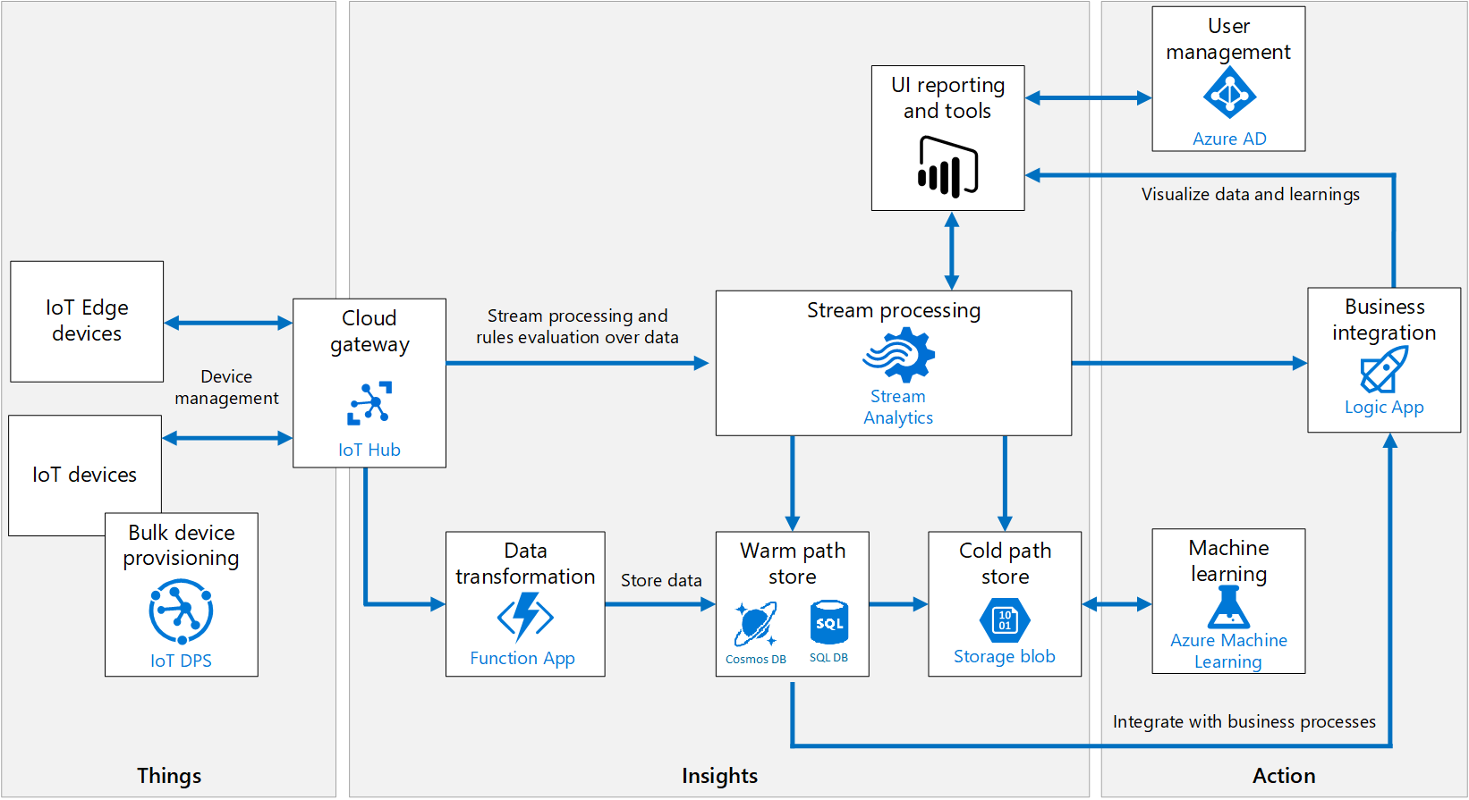

Figure 7 Azure IoT Ecosystem extracted from Microsoft Azure Cloud Service

Azure Stream Analytics is a real-time streaming engine that is designed to process high volumes of fast streaming data from multiple sources simultaneously. Once the relationships between input sources RPi in IoTHubs and output sources such as streaming as a dataset in Power BI has been formed, it will trigger the streaming of real-time sensory data from IoT device to Power BI. The Figure 8shows the real-time metrics of the status during data streaming between the input source and output source.

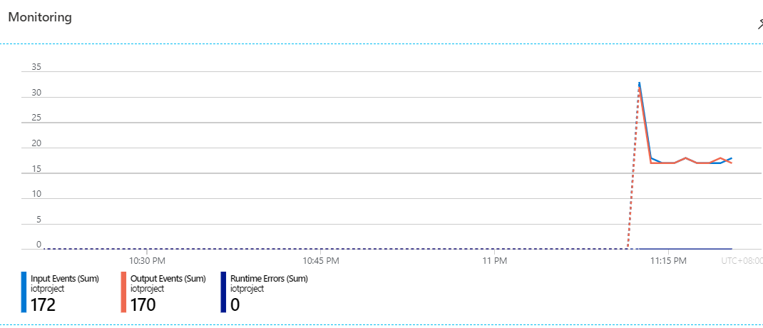

Figure 8 Real-Time Metrics from Azure Stream Analytics

The field parameters obtained are tabulated as below. These parameters are added dynamically as a new row in the dataset “sensortest” of Power BI during streaming.

Table 3 Table Summary of sensor data in Power BI

|  |  |  |
| --- | --- | --- |
| **Table Name** | **Field** | **Type** |
| sensortest | ConnectionDeviceGenerationID | Text |
| ConnectionDeviceID | Text |
| CorrelationID | Text |
| Enqueued Time | Date/Time |
| Humidity | Decimal Number |
| MessageID | Text |
| Temperature | Decimal Number |

# **Data Visualisation**

# **VR**

The add-on of Autodesk Revit named “Prospect”, which is developed by IrisVR will be used for VR visualisation, the model data in BIM360 can be opened in Revit and the model will be converted for VR visualisation by using this plug-in. It can create a narrative for the VR experience which is in 1:1 scale. Besides, Prospect is the only one that include all utility features such as measurement, mark-up, snapshot, section view and object information in a single add-on compared with others in the market and it provided free-trial for 14 days, so it has been chosen for this study.

The immersive VR headset Oculus Quest will be used for this study. It is a completely wire-free, PC free and with all the sensors built in. The specification is as follows:

Table 4 Specification of Oculus Quest

|  |  |
| --- | --- |
| Display panel | OLED |
| Display resolution | 1440 x 1600 per eye |
| Refresh rate | 72Hz |
| CPU | Qualcomm Snapdragon 835 processor |
| RAM | 4GB RAM |
| Battery | Lithium-ion battery with 2-3 hours playtime, depending on what you are playing |
| Degree of Freedom | 6 degrees of freedom head and hand tracking |
| Controllers | Two touch |
| Weight | 571g |

# **Dashboard**

As Power BI can get data from a large numbers of source such as Azure SQL database and Streaming Analytics after the connection has been set up, a dashboard created by Power BI will be used to visualise the construction performance data and sensory data. Also, whenever the data has been updated in the data source, one can just click the refresh button in Power BI to make a new query to update data. It also supports publishing to the internet as a report and embedded into other websites such as BIM 360, which enhance the integration with the CDE, a local dashboard file stored at this github link for reference.

# **Connectivity**

Forge API by Autodesk is used to demonstrate the connectivity feature of the Control Room. It comprised of multiple APIs for retrieving different kinds of data for specific group of tasks related to the Autodesk cloud ecosystem. The data such as model data, checklist, issues can be further developed for automated processes, workflows, and data visualisation. All the available API can be explored on <forge.autodesk.com>.

A web-based viewer application has been developed which makes use of the Forge API to push the model data from sources like BIM 360 to the graphics rendering engine by Autodesk, which is a WebGL-based, JavaScript library for 3D and 2D model rendering. This application provides a way for the external stakeholders and non-technical person (e.g. public) to read the BIM model data, which allow them to get the rich information from the building and its nearby environment with the 3D models. The script is attached in Appendix xx.

# **GitHub Repository**

All the script developed can be found on the Github[4] page of this study.

# **Result & Discussion**

The result focus on the evaluation and how is the Control Room’s features to achieve effective information management, insightful data visualisation and data connectivity to external applications based on the case study of residential house project.

# **BIM360**

# **Document Management**

The module “Document Management” provides ways to identify the change of information effectively. In the case study, the structural team members can find out what modification by architectural team has been added in the model file, they can compare the versions of the model and all the additional features will be highlighted as Figure 9. The features which are highlighted in green is the additional elements added by other team members and the part highlighted in yellow indicate the building elements that have been modified.

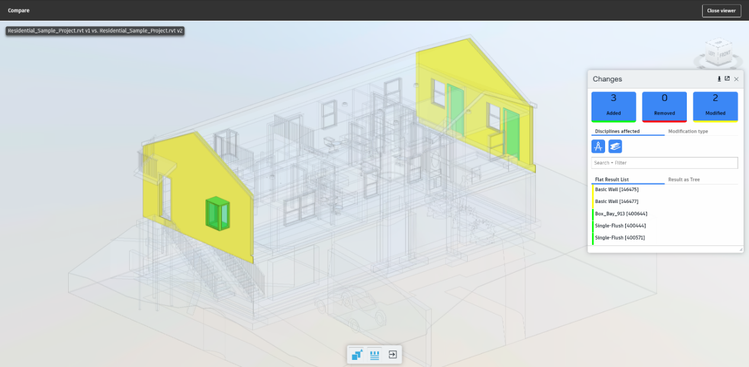

Figure 9 Comparing the difference between models by BIM 360 Document Management

Besides, it shows that the quality assurance process on document can be digitalised to enhance its integrity. The workflow approval function is a set of step-by-step requirements that the team members should fulfil to make sure the quality of documents like BIM model fulfil certain standard to be approved.

For example, the structural engineer have identified the changes of model by architect and added the respective structural elements to support the architect’s change, he would like to submit the updated model to his designated team members to review, he can select the model and choose the desired workflow based on different requirement and assign to the manager for review. An email notification window will be automatically sent to the manager afterwards. Then, the reviewer can make mark-ups and add comments to the model. And it can be sent back to the project engineer for amendment and the workflow only can go to the next step only when all the comments have been resolved.

This function ensure the quality of the information that it should be compromised for going to the next step and no need to spend extra-time to return to previous step to re-do the works under the traditional working practice as there was no strict workflow approval procedure. Also, it has recorded who have already received the notification for review the document and who need to answer the queries, so it pushes the team members act on time to increase the productivity of works.

# **Design Collaboration**

The “Design Collaboration” module provides a way to enhance the collaboration with different team members. For example, the structural engineer has modified the model with extra structural elements such as beam, columns and walls based on that model. Once they have completed the modification, the structural engineer can synchronize and publish the model data to the BIM 360 for other teams. On the web-platform of BIM 360, the structural engineer can create a package in the timeline as shown on Figure 10 so that the packages can be shared to other teams to consume this model and keep on modifying it.

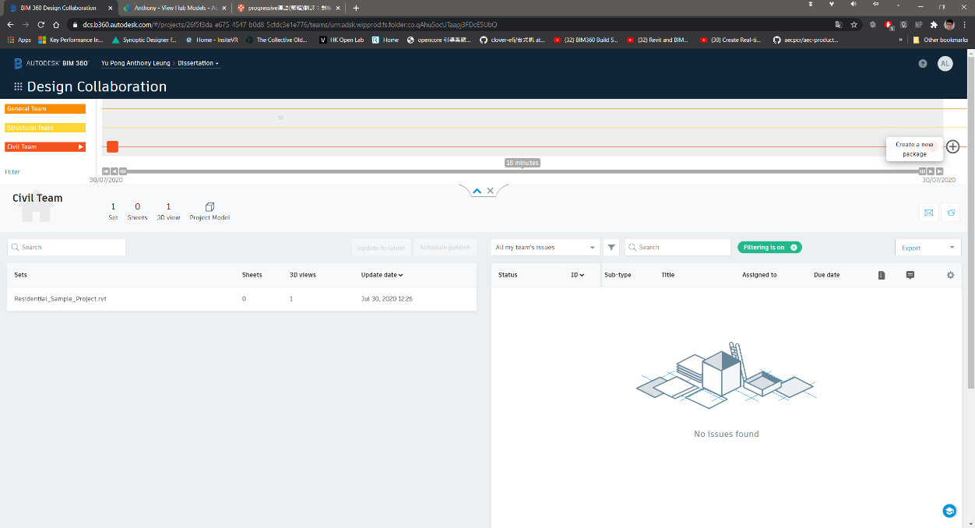

Figure 10 Overview of BIM 360 Design Collaboration Module

This design collaboration loop function provides a set of collaboration procedure can achieve a continuous and smooth handover of the model data between different team members.

# **Project** **Management**

The “Project Management” module provides a way to keep the RFI record clearly between different team members. For example, the structural engineer discovered the chimney wall outside the house will be conflict with the structural wall inside the building and they would like to ask relevant teams such as the architectural team whether it is possible to relocate the chimney wall. The structural engineer can issue an RFI as the Figure 11. The structural engineer can also add a push pin in the model to let the architect understand the situation clearly. Once it is submitted, the architect will be notified to make his decision automatically. All of these have recorded on the module and no need to spend extra-time to search loads of email like the traditional practice to keep track on the status of the RFI.

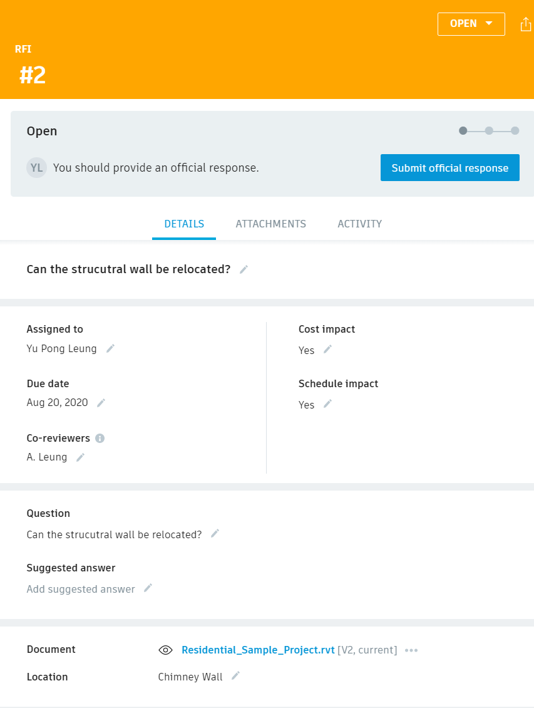

Figure 11 RFI form from BIM 360

# **Limitations**

The digitalised workflow approval and RFI functions by the first two modules set a good illustration of how effective collaboration and information management can be achieved. However, the “design collaboration” module is a bit complicated and it created multiple model data files which may lead to confusion. For example, after the publish of the model data by one team member to the BIM 360, the model will be saved in the folder named “WIP (Work in Progress) folder” on the BIM 360, which is created automatically under the work breakdown structure of the design collaboration module. Besides, as the user need to create a package to share to other team members, the model data will be saved automatically in folder “Shared” after it is confirmed to share to other team members for consume. And finally, after the model has been consumed, the model will be saved in the folder named “Consume”. As a result, multiple model data files have been created by using this design collaboration loop concept and it may make confusion to the beginners that they do not understand which model they should be used to work with if they are not familiar with the design collaboration concept.

# **VR**

# **Project Perception**

The VR visualisation gives a great perception of the construction environment for multiple team members. First, the residential house model data has been parsed with the software “Prospect”. Different team members can either fully immerse in the 3D models data with the VR headset (right of Figure 12) or visualise the 3D environment with the computer (left of Figure 12). It gives a great perception for the project team members especially the newcomers to understand how the construction environment would be instead of imagination from the traditional drawings. As it is not uncommon that there are many newcomers ranged from workers to engineers to join a typical construction project every working day, and they need to understand the project as fast as possible to work with productivity. As a result, the VR visualisation plays an important role form them to understand the construction environment in a faster way.

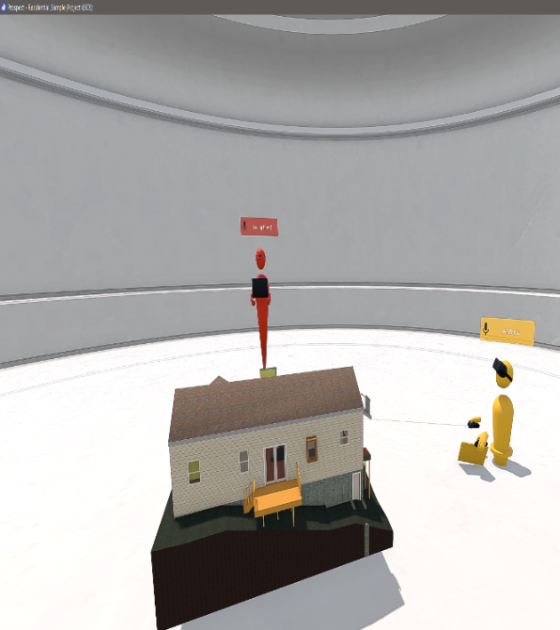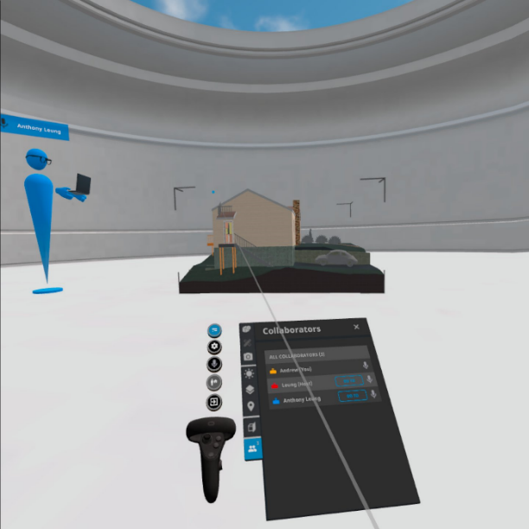

Figure 12 Different Team member immerse in 3D environment

Besides, team members can also carry out VR remote meeting to review the modification need from other teams. For example, they can make use of the utility features such as measurement, mark-up tools, object details and sectional view for the user to present their idea during the remote meeting effectively. The building service engineer (blue) can use the mark-up tool to add annotations and comments on the ceiling of a specific room so that the structural team member (yellow) can adjust the setting out of the structural beam to avoid crash with this building services utilities during VR inspection. The video link of the demonstration is …

After they have agreed how they would modify their design and the construction sequence in the VR inspection, team members can have a clear understanding of the need of other members. They can amend their own respective data model and combine with the use of design collaboration module in BIM 360. As a result, different team members can modify the model effectively and avoid crash of elements, which greatly increases the productivity. This form of remote working is useful if the team member cannot access to office and site.

# **Safety Hazard Identification**

Besides, it is a useful to identify locations with safety hazard. As the user can visualise the model from it very beginning to the final completion stage. All the safety hazards during the construction can be identified and find out the exact locations with the high risk of safety deficiency such as confined space, locations which easy to fall from height. For example, the balcony at the west evaluation of the residential house which is above ground for 2.45m meters and at the edge location as Figure 13, which is highly susceptible to the hazard of falling from height. This can help the managers to arrange special training for workers such as working on height and pay more attention to this location during the construction of the balcony.

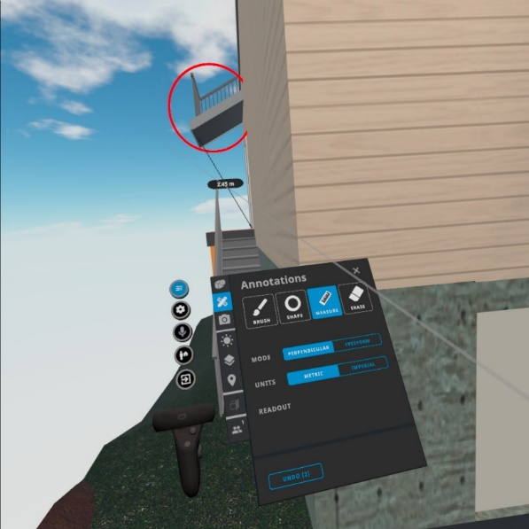

Figure 13 Identifying Safety Hazard

# **Limitations**

VR can provide a great environment for collaboration and identify location with safety hazard for the users. However, the subscription cost is not competitive enough and often exists as a separated plug-in or services rather than integrated with the collaborate tools. It made individual need to pay extra cost to buy this service to use, which lower the motivation for the construction professionals to adopt this technology. According to two services providers like Prospect by IrisVR and “the Wild”, their monthly subscription is about $225 USD and $295 USD respectively, which is not an affordable price for some small size company to adopt this solution.

Besides, the compatibility of add-on of “Prospect” should be improved. For example, one must need to open the local desktop software Autodesk Revit to load the model data from the cloud BIM 360, and use the VR add-on in Revit to transfer the BIM model data its external VR software “Prospect” to parse the model data so that we can visualise the immersive VR environment on the external software which shown on the Figure 14. To make it more user-friendly, it should be integrated in the cloud platform of Control Room (such as BIM 360), so that when all the project team members access to the cloud platform, they can open the model file and then press one button to access the immersive VR environment for walkthrough and remote meeting immediately rather than installing external software and so many steps to start with the visualisation with VR.

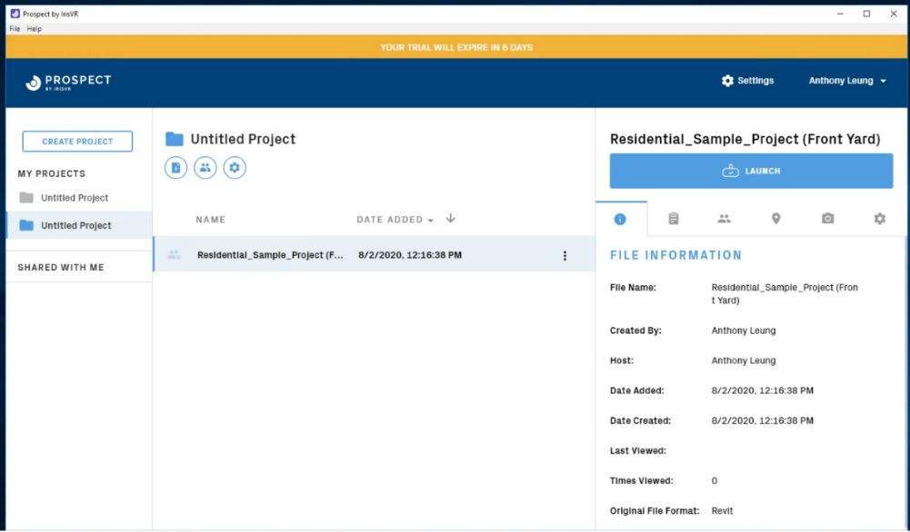

Figure 14 Overview of Prospect

# **Dashboard**

# **Identify Insight from Safety Record**

In the first dashboard (Figure 15), we can identify that the trend of the number of accidents of constructing the residential house is decreasing across the years from 2016 to 2020 and the basement with the highest number of accidents. One can choose whatever categories under different indicators such as “Severity”, “body part”, “main activity”, “Risk Category” and “Injury Type” so that the total number of fatalities, incidences and the number of accidents across different years will be changed. It is easy to identify that most of the accidents belongs to the activity of concreting , category of risk with slip or trip on the same level, workers suffering from body parts such as leg and the severity of most of the case is low.

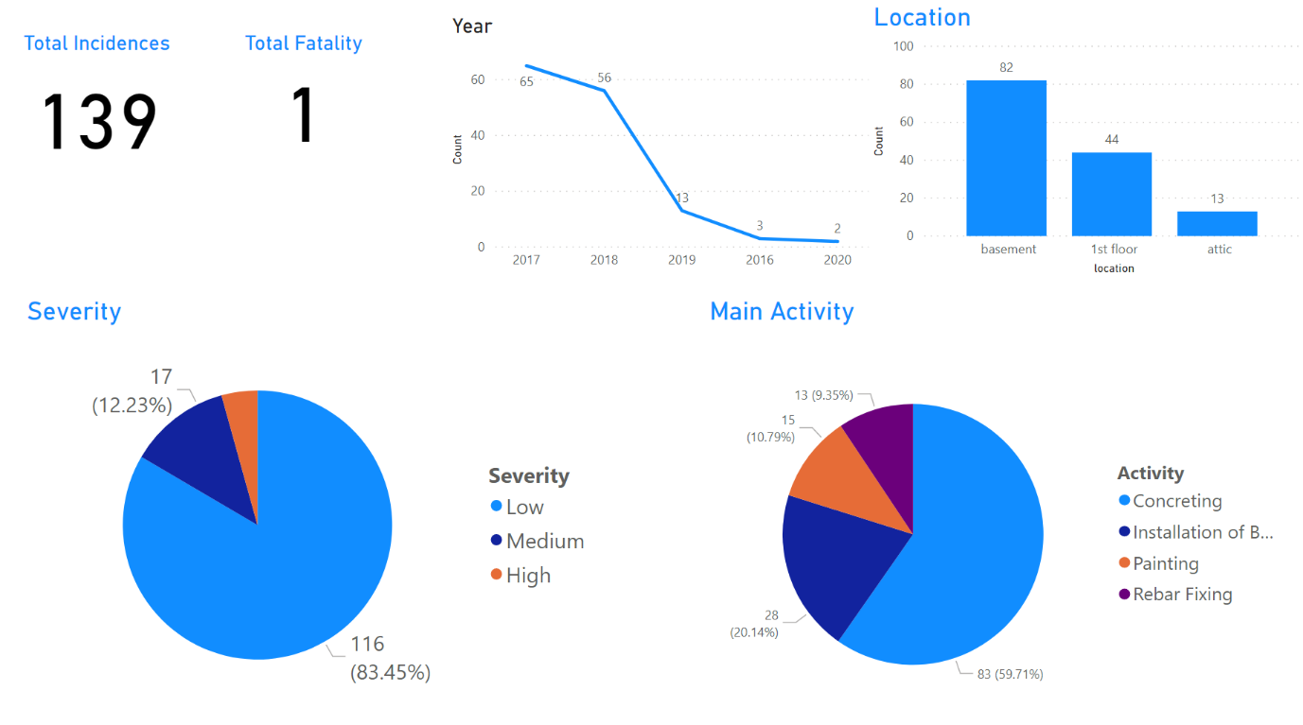

Figure 15 Dashboard Visualisation by Power BI - Overview

According to these messages provided via this dashboard, the project managers should pay more attention to the activity like concreting and the location of basement. **The managers can make investigation to see the causes lead to the workers suffering from high risk of accident in the basement when concreting**. Besides, the managers can provide more personal protection equipment to protect the legs of the workers.

Besides, **the second dashboard use a tree level diagram, which shows the root on how to constitute the number of accidents.** The tree diagram (Figure 16) has separated into different levels, the first one is “nature of injury”, second is “activity”, third is “location” and the last one is “no of day lost”. For example, when we selected one of category under the first level “severity”, then the number of accidents will be separated into different groups under the second level “location’”. And then it will separate into different groups under the third level “activity”, when we click one of the group, the number of accidents will be separated in different groups again under the forth level ‘body part’, so that we can identify the number of accidents based on different level of a specific root.

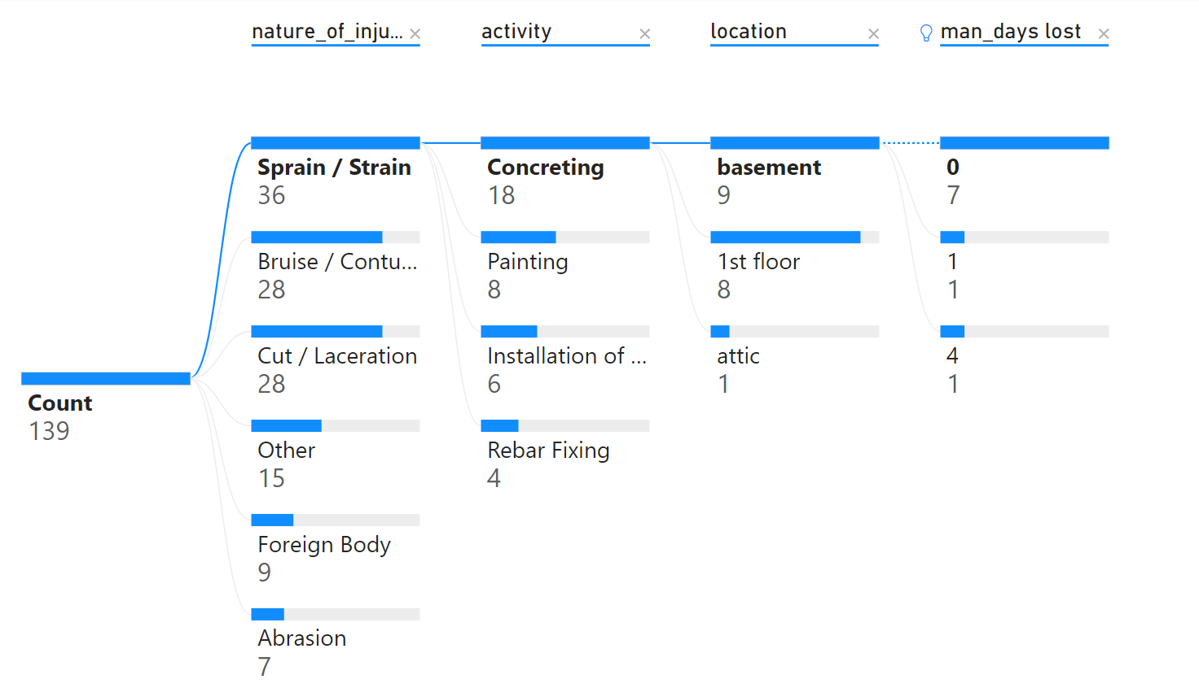

Figure 16 Dashboard Visualisation by Power BI – Tree Diagram

The Project Managers can easily identify which construction activities at its respective location to cause different types of the nature of injuries and the productivity lost. It gives a chance for the project manager to identify each nature of injury concentrated on what activities and where its location and how to affect the productivity lost.

# **Monitoring the Working Environment**

The real-time sensory data has been visualised with line chart in Power BI dashboard. Overall, xxx data points were collected on [date]. The variation of the temperature and the humidity of the working environment has been captured on the Figure 17. The project engineer can make use of the sensory data to monitoring the working environment of the workers. If the temperature and humidity achieved a level not suitable for the workers to work, **the project engineer can ask the workers to take regular break.**

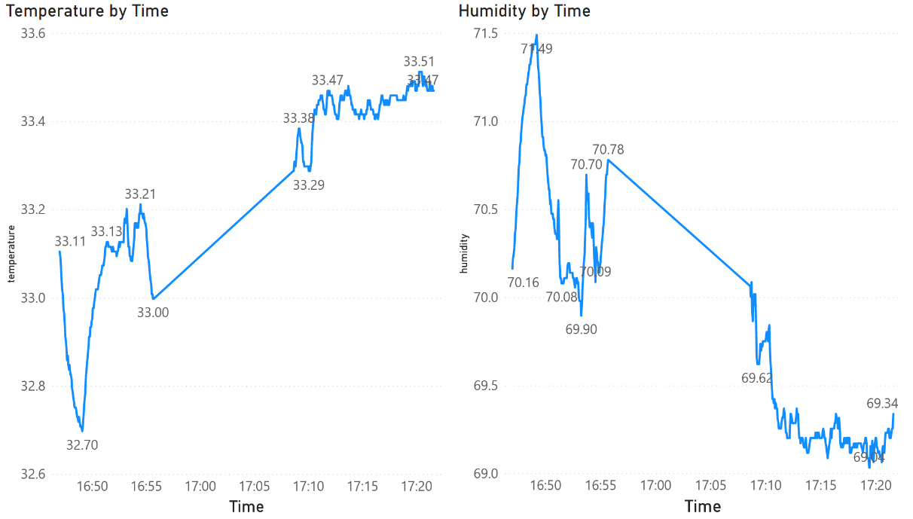

Figure 17 Line Chart Visualisation of Sensory Data by Power BI

# **Limitation**

The Power BI is a great platform to present the data to give insight, pattern and abnormality. However, based on the availability of the dataset, the author cannot find data to establish a KPI for monitoring the construction performance. The maybe due to as AEC industry is complicated in nature, different construction companies will have their own standard and indicators to report the project safety, progress related issue and workflow for quality assurance process. As a result, there is no common objective benchmark for the AEC industry to compare the construction performance such as construction KPIs. The AEC industry should try to agree a set of KPIs so that the construction performance of every company can be compared based on these KPIs and the dashboard features of the Control Room system can make use of this common standard for comparison.

Besides, the project manager should not misattribute causality when comparing elements on the dashboard. The dashboard result show that most of the accident record concentrated on the location of basement while the number of accident on the attic is the lowest, but it just means the location of basement is more likely to have accident compared with attic based on the old record, the project managers should also think about the nature of the construction works whether it is different from the basement so that the old record cannot be as the sole guideline to set up safety policy and resource allocation to mitigate the problem.

# **Recommendation**

For the use of sensory data, a more accurate result of the working environment can be achieved by installing multiple sensors at different location so that the environment data would not be biased on one location. However, it would cost much higher and the project manager maybe no motivation to this technique if the sensory data cannot give a big return. Apart from that, dashboard is not the best way to visualize the sensory board, it would be much for useful if it can be visualized in the VR environment so that it gives a much better perception of the status of working environment during remote working. However, it involved high technical knowledge and still developing for practical usage recently.

# **Connectivity with External Applications**

This viewer application (shown as Figure 18) developed with Forge API can provide an external access for the non-technical users such as the public or the client, which enhance the transparency of the project delivery. The users can use the toolbar below the 3D model for the users to navigate the model and be familiar with the building information stored in each building elements. For example, the client of this project can utilize this viewer to gain better perception of the interior environment before it has constructed and get the detailed information provided by the 3D model. Real-time sensory data can also link to this model such that the public can understand how the construction works impact to the nearby environment.

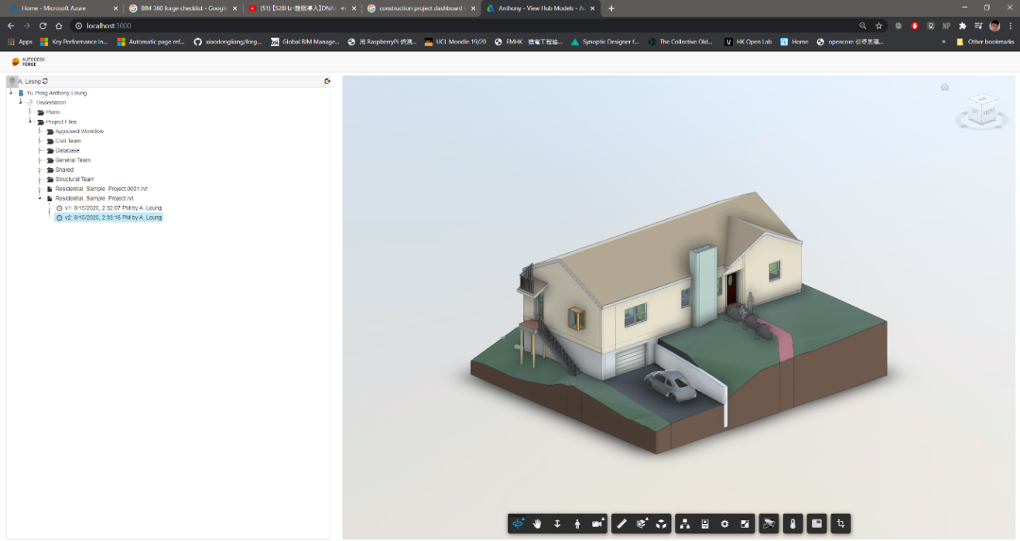

Figure 18 Overview of Viewer Application

# **Challenges**

Due to some technical challenges, the author is only able to develop a simple viewer application to demonstrate the connectivity feature of the Control Room, which is not compelling enough to illustrate this feature. Although Autodesk already provide documentation to develop different applications on the internet, it is highly fragmented and not easy to start with. The author originally wants to integrate the sensory data into the BIM model data to provide more information for visualisation. However, it is very difficult to manually to integrate the viewer application and the sensory data by coding.

# **Recommendation**

Regarding to this issue, it is suggested that a visual programming interface which is similar to the “makecode[5]” for developing applications for microbit should be provided on the API feature of the Control Room so that the user can more easily to customise on how to push data to or get data from other external applications. Since the technology adoption in AEC industry is not strong enough and not many construction professionals with IT background, a visual programming interface can set a good starting point for the construction professional to customise their use.

Besides, the connectivity feature plays an important role to ensure all the project data can be more integrated and for further analysis. As there are different external proprietary mobile applications used by contractor companies to record the productivity of the frontline workers, share construction information like mark-up drawings, progress photos and issues tracking in the construction site. The Control Room should have the connectivity to get and process the data from these external applications such that these data can be gather to the common data environment of the Control Room for storage and visualisation. The project data should also be connected to other external cloud server for processing such as Machine Learning algorithm, which makes the Control room functions scalable and expand its computation power.

# **Day-to-Day Routine of Control Room**

Although some of the Control Room features cannot be demonstrated as expected due to some technical challenges, it shows the ability it could be and its improvement. A day-to-day operation of the Control Room on the residential house design and build project can be illustrated as follows:

First, the engineer can access to the web-based BIM 360 platform to understand the status of different workflow requested for approval, RFI submitted by other team members at ”Project Home” page. Then he can use the local software Revit to access to the BIM model data stored in BIM 360 to review and modify the model to resolve the issue raised. If the engineer not sure whether his modification on the model can fulfil the need by the architect, they can hold a VR remote meeting to present themselves in the model, they can discuss together in a 3D immersive environment to comprise a design which can fulfil the need of both teams. It can increase the productivity and avoid the re-do works. During the construction stage, the engineer can use the sensory data to realise the environment condition of the construction site to check whether the working environment is suitable for working. If the temperature always above the threshold of working, the engineers should ask the workers to take regular breaks to maintain their health to work.

Apart from the project engineers, the project managers and project directors can make use of the dashboard to oversee the accidents record at the construction site to identify which locations, construction activities will cause high safety risk so that they can set up strategies to mitigate the safety deficiency such as provide extra PPE when concreting at basement and set up goals to maintain the safety record and ask the project engineer to keep on monitoring it. They can also use the VR visualisation with BIM model data to conduct a walk-though in an immersive 3D environment for site inspection to identify any locations with high risk during construction and construction constraints to facilitate their planning of resources and cost of the project.

Besides, the engineer can also access to the control room to get more detail information such as the workers productivity, progress photos from the construction site which captured by other external applications. He can also push the information he wants to the cloud sever which with high computation power.

Apart from the working professionals, the general public and client can also access to the online viewer application to understand the progress of the construction works, the building information and how the construction works would affect the environment at the real-time.

The video link shows the day-to-day operation:

# **Future Development (200 words)**

In the future study, there are numerous possibilities of the functionality of the Control Room.

real-time sensory data with the BIM model in VR

# **Conclusion (300 words)**

(Link to Intro, LR, Digital Twin!!!)

We set out to explore x and learnt y

The applications evaluated in this study give an overview of how the Control Room’s features has been developed and how should it be improved. It shows that from the Project Engineer to the Project Director will also get benefit from it for their day to day operation of a construction project.

Through a literature review, ….

To provide more comprehensive and detailed review on the functionality of a Control Room, this study evaluated multiple functionality that were available on the market recently. Application such as BIM 360, Prospects, Autodesk Forge API, Microsoft were identified and evaluated.

Their capabilities were evaluated including information management, data visualisation and connectivity

Recommendations were given on how these features should be improved to make it to use more effectively and easy to use.

# **Reference**

Alizadehsalehi, S., Hadavi, A., & Huang, J. C. (2019). Virtual reality for design and construction education environment. *AEI 2019: Integrated Building Solutions - The National Agenda - Proceedings of the Architectural Engineering National Conference 2019*. https://doi.org/10.1061/9780784482261.023

Bennett, S. (1993). A History of Control Engineering 1930-1955. In *A History of Control Engineering 1930-1955*. https://doi.org/10.1049/pbce047e

Boje, C., Guerriero, A., Kubicki, S., & Rezgui, Y. (2020). Towards a semantic Construction Digital Twin: Directions for future research. In *Automation in Construction*. https://doi.org/10.1016/j.autcon.2020.103179

Bolton, A., Butler, L., Dabson, I., Enzer, M., Evans, M., Fenemore, T., & Harradence, F. (2018). The Gemini Principles. *University of Cambridge, UK 2018*. https://doi.org/10.17863/CAM.32260

Brandon, J. (2020). *VR is the future of remote working*. https://www.techradar.com/news/vr-is-the-future-of-remote-working

Changali, S., Mohammad, A., & Van Nieuwland, M. (2015). The construction productivity imperative. *McKinsey Quarterly*.

Chhaya, M., Juneja, S., Smaje, K., & Sukharevsky, A. (2020). *Driving digital change during a crisis : The chief digital officer and COVID-19*. Mckinsey Digital. https://www.mckinsey.com/business-functions/mckinsey-digital/our-insights/driving-digital-change-during-a-crisis-the-chief-digital-officer-and-covid-19

*Design–build*. (2011). https://en.wikipedia.org/wiki/Design–build

Engineers, I. of C. (2018). *P13 Blue Print*.

Freina, L., & Ott, M. (2015). A literature review on immersive virtual reality in education: State of the art and perspectives. *Proceedings of ELearning and Software for Education (ELSE)(Bucharest, Romania, April 23--24, 2015)*. https://doi.org/10.12753/2066-026X-15-020

HSE. (2019). Work-related stress , anxiety or depression statistics in Great Britain , 2019. *Annual Statistics*.

Jarrett Hendricks. (2020). *Rise of the Digital Twin: How Lessons Learned from NASA Are Changing the Way Supply Chains Are Managed*. https://info.expeditors.com/horizon/rise-of-the-digital-twin

Lara, A. P., Da Costa, E. M., Furlani, T. Z., & Yigitcanlar, T. (2016). Smartness that matters: Towards a comprehensive and human-centred characterisation of smart cities. *Journal of Open Innovation: Technology, Market, and Complexity*. https://doi.org/10.1186/s40852-016-0034-z

Levine, T. (2016). *Using Communication and Collaboration Technology to Keep Construction Projects On Schedule and On Budget*.

Li, X., Yi, W., Chi, H. L., Wang, X., & Chan, A. P. C. (2018). A critical review of virtual and augmented reality (VR/AR) applications in construction safety. *Automation in Construction*. https://doi.org/10.1016/j.autcon.2017.11.003

McKinsey. (2015). The MGI Industry Digitization Index. *McKinsey Global Institute*.

McKinsey & Company. (2017). Reinventing Construction: A Route To Higher Productivity. *McKinsey & Company*.

Microsoft. (2020). *Azure Cloud Services*. https://azure.microsoft.com/en-us/overview/what-is-cloud-computing/

Mohd Nawi, M. N., Baluch, N., & Bahauddin, A. Y. (2014). Impact of fragmentation issue in construction industry: An overview. *MATEC Web of Conferences*. https://doi.org/10.1051/matecconf/20141501009

Stergiou, C., Psannis, K. E., Kim, B. G., & Gupta, B. (2018). Secure integration of IoT and Cloud Computing. *Future Generation Computer Systems*. https://doi.org/10.1016/j.future.2016.11.031

Woodhead, R., Stephenson, P., & Morrey, D. (2018). Digital construction: From point solutions to IoT ecosystem. *Automation in Construction*. https://doi.org/10.1016/j.autcon.2018.05.004

Xu, S., & Luo, H. (2014). The information-related time loss on construction sites: A case study on two sites. *International Journal of Advanced Robotic Systems*. https://doi.org/10.5772/58444

Yi, Y., Yan, Y., Liu, X., Ni, Z., Feng, J., & Liu, J. (2020). Digital twin-based smart assembly process design and application framework for complex products and its case study. *Journal of Manufacturing Systems*. https://doi.org/10.1016/j.jmsy.2020.04.013

Zhuang, C., Liu, J., & Xiong, H. (2018). Digital twin-based smart production management and control framework for the complex product assembly shop-floor. *International Journal of Advanced Manufacturing Technology*. https://doi.org/10.1007/s00170-018-1617-6

# **Research Log**

|  |  |  |  |
| --- | --- | --- | --- |
| **Date** | **Task** | **Challenges** | **Solutions** |
| 16/04 | Draft literature review | Struggling to find literature in my exact topic area | Widen research search (e.g. other disciplines)  Speak with supervisor for recommendations |
| 16/05 | Meeting with supervisor |  |  |

# **Appendix**

1. Design and Build Project means that design and construction ongoing at the same time (*Design–build*, 2011)
2. Reference Link: <https://projectdataanalytics.uk/past-events/projecthack5-output>
3. Reference: <https://en.wikipedia.org/wiki/Request_for_information>
4. <https://github.com/ypleungaa/Control_Room_AEC_Industry>
5. Microsoft’s MakeCode editor makes use of the colour-coded blocks for the users to start programming and get creating with the BBC micro:bit. <https://makecode.microbit.org/>